Concrete Diction

🧱 What is Concrete Diction
# Source: Chatgpt (GPT-4-turbo) at [7/30/2025]
Concrete diction uses specific, sensory, and tangible words that describe things we can see, hear, smell, touch, or taste. It refers to physical objects, actions, or conditions that are real and observable.

✅ Key Features:
# Source: Chatgpt (GPT-4-turbo) at [7/30/2025]
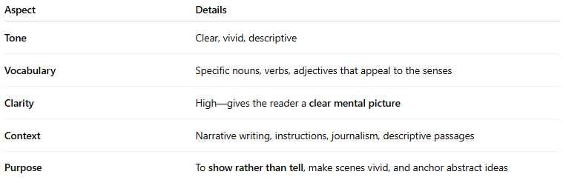
Aspect | Details
Tone | Clear, vivid, descriptive
Vocabulary | Specific nouns, verbs, adjectives that appeal to the senses
Clarity | High—gives the reader a clear mental picture
Context | Narrative writing, instructions, journalism, descriptive passages
Purpose | To show rather than tell, make scenes vivid, and anchor abstract ideas

🧠 Examples of Concrete Words:
# Source: Chatgpt (GPT-4-turbo) at [7/30/2025]
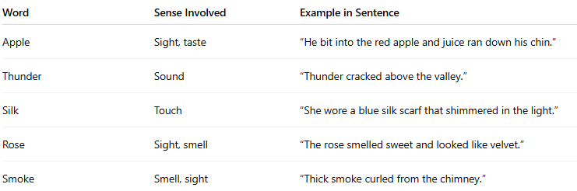
Word | Sense Involved | Example in Sentence
Apple | Sight, taste | “He bit into the red apple and juice ran down his chin.”
Thunder | Sound | “Thunder cracked above the valley.”
Silk | Touch | “She wore a blue silk scarf that shimmered in the light.”
Rose | Sight, smell | “The rose smelled sweet and looked like velvet.”
Smoke | Smell, sight | “Thick smoke curled from the chimney.”

✍️ Example Sentences Using Concrete Diction:
# Source: Chatgpt (GPT-4-turbo) at [7/30/2025]
- “A rusty nail pierced his boot and sank into his heel.”
- “She poured steaming coffee into a chipped ceramic mug.”
- “The puppy's fur was soft, and it whined softly as it nuzzled her hand.”

🔍 Concrete vs. Abstract Diction:
# Source: Chatgpt (GPT-4-turbo) at [7/30/2025]
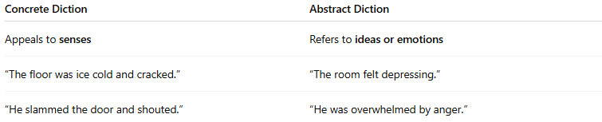
Concrete Diction | Abstract Diction
Appeals to senses | Refers to ideas or emotions
“The floor was ice cold and cracked.” | “The room felt depressing.”
“He slammed the door and shouted.” | “He was overwhelmed by anger.”

🧭 Used In:
# Source: Chatgpt (GPT-4-turbo) at [7/30/2025]
- Narrative and descriptive writing
- Journalism and reports
- Instructional and technical texts
- Realistic dialogue

